Celestial Forest presents…

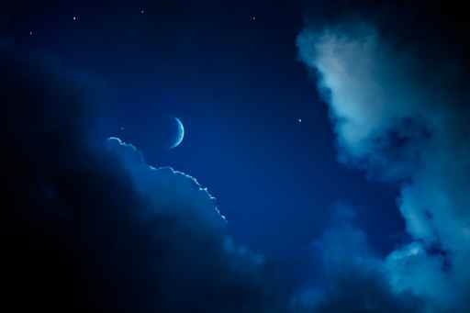
New Earth Creatrix

Discover a Deeper Direct Relationship to the Sacred

New Earth Creatrix

Tracking Sheet 2021

Name You Are Enrolled in the New Earth Creatrix Circle Under:
Name You Want to Have on Your Certificate:
Email:
Phone:
Emergence Date:
This tracking document is for you to keep track of where you are in the process. If you would like a certificate of completion at the end of the process you will need to send it in to the office after your emergence. Three-feathers@hotmail.com
Place in the empty space for each week for yourself the date you listened to the program and one or two insights you received. The bonuses are not required. Use as much space as you need. Tracking is essential for you to receive a completion certificate.

Module 1
Exploring the New Earth Creatrix archetype

Deepening your connection to the living field of creation

Diving into the sacred alchemy of creativity and receiving

How to choose a New Earth Creatrix Process intention

Module 2
How to fully express your creation energy

How to align your creative flow with your intention in a way that generates results. Creatrix Project Training

How simple vs complex impacts your creation results

Releasing starving artist archetype (even if you don’t think you have it). Preparation for Initiation Ceremony

Module 3
Fully accessing the New Earth Creatrix within. Initiation Ceremony

Module 4
Releasing old patterns that block the merger of spiritual/creative/financial flow. Releasing spiritual ego traps such as piety, so you can fully receive the New Earth Creatrix flow from the garden of earthly delights. Living and creating from your highest frequency while honoring your human experience.

Module 5
Magically aligning with mastery skills like a true alchemist

Align, activate, embody, and transmit the Goddess Stargate pattern

Module 6
Stargate Goddess pattern activation continued

Dancing with the New Earth Creatrix through up-leveling your skills. The poison darts to watch out for and how to keep them from railroading your creation energy

Module 7
Competition vs creation: the critical truth and what to do about it

Ancient alchemical wisdom teachings

Connecting to and receiving guidance from Maria Prophetissa

Accessing the potent substance called prima matta by the alchemist to bring your creations from the formless into form

Module 8
Working with the first stage of alchemy: Calcination

How this stage impacts your business, your money, your creations, and your fulfillment

Module 9
Working with the second stage of alchemy: Dissolution

How this stage impacts your business, your money, your creations, and your fulfillment

Module 10
Working with the third stage of alchemy: Separation
How this stage impacts your business, your money, your creations, and your fulfillment

Module 11
Working with the fourth stage of alchemy: Conjunction

How this stage impacts your business, your money, your creations, and your fulfillment

.

Module 12
Working with the fifth stage of alchemy: Fermentation

How this stage impacts your business, your money, your creations, and your fulfillment

Module 13
Working with the sixth stage of alchemy: Distillation

How this stage impacts your business, your money, your creations, and your fulfillment

Module 14
Working with the fourth stage of alchemy: Conjunction

How this stage impacts your business, your money, your creations, and your fulfillment

Module 15
Alchemical Integration as a New Earth Creatrix

Module 16
Alchemical Creation, Receiving, and Money Mysteries – Spirit

.

Module 17
Alchemical Creation, Receiving, and Money Mysteries – Earth

Module 18
Alchemical Creation, Receiving, and Money Mysteries – Water

Module 19
Alchemical Creation, Receiving, and Money Mysteries – Air

Module 20
Alchemical Creation, Receiving, and Money Mysteries – Fire

Module 21

Clearing the New Earth Creatrix Vessel

Module 22

Clearing the New Earth Creatrix Vessel

Module 23
The magical alchemical meaning of the Wheel of the Year Points and how to utilized them as a New Earth Creatrix

Module 24:
The Living Field of Creation at the Creatrix level

Module 25
Required New Earth Creatrix Transfiguration Journey

Module 26
Galactic Council and Elemental StarMaiden Goddess Guidance
Module 27
Preparing for Emergence, Process Review, Preparing your own ceremony or preparing for group ceremony.

Module 28
Emergence
Your Overall Experience with the Process:
Suggestions for the Process:

Quote for promotion & permission to use. If we can also use a photo of you please send along:

Would you like to be issued a certificate of completion? Yes/No

