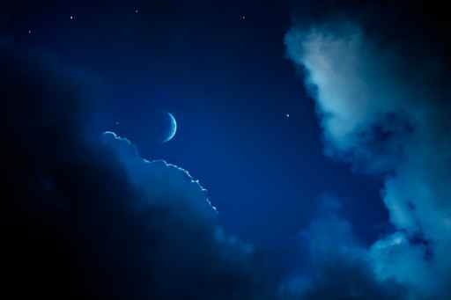
The StarMaiden Priestess ProcessTM

Discover a Deeper Direct Relationship to the Sacred

StarMaiden Priestess Process Tracking Sheet
Name:
Email:
Phone:
This tracking document is for you to keep track of where you are in the process. If you would like a certificate of completion at the end of the process you will need to send it in to me after your emergence. Three-feathers@hotmail.com
Place in the empty space for each week for yourself the date you listened to the program and one or two insights you received. The bonuses are not required. Use as much space as you need. Tracking is essential for you to receive a completion certificate.
Module 1
Exploring the Priestess and Alchemical Creation Priestess archetype, New Earth Consciousness, Priestess process lineage line
Module 2
Learn about living ceremony, Creating a clear intention for the process, Preparation for Initiation Ceremony, Activating your Divine Blueprint
Module 3
Understanding the alchemical transformational process. Learning to identify and clear pieces that arise during the process and clearing the Priestess Archetype Meditation.
Module 4
Libra New Moon Online Initiation Ceremony
Module 5
Elemental Forces of Creation Wisdom, The Unified Field of Creation, and Activate Your Inner Oracle

Module 6
Priestess Connection to the core of alchemy and creation the Elemental Forces. The priestess elemental of Earth and the Temple of the Living Earth.

Module 7
Priestess Connection to the core of alchemy and creation the Elemental Forces. The priestess elemental power of Water.
Module 8
Priestess Connection to the core of alchemy and creation the Elemental Forces. The priestess elemental power of Air.
Module 9
Priestess Connection to the core of alchemy and creation the Elemental Forces. The priestess elemental power of Fire.
Module 10
Priestess Connection to the core of alchemy and creation the Elemental Forces. The priestess power of Spirit. Becoming the Hollow Bone and Accessing the Source of the Sacred.
Module 11
Star Maiden Circle Moon cycle and Life Map.

Module 12
Alchemical Creation Priestess Life Purpose Skills and Gifts- Section One
Module 13
Alchemical Creation Priestess Life Purpose Skills and Gifts- Section Two

Module 14
Alchemical Creation Priestess Life Purpose Skills and Gifts- Section Three

Module 15
Feminine and Masculine Principles Alchemically Unite in Co-Creation
Module 16
The Divine Feminine Connection and Healing, Preparation for your honoring the Divine Feminine in Creation Ceremony

Module 17
The Divine Feminine Yin and Yang

Module 18
The Divine Masculine Connection and Healing, Preparation for your honoring the Divine Masculine in Creation Ceremony

Module 19
The Divine Masculine Yin and Yang
Module 20
Inner Sacred Marriage Ceremony: Uniting your feminine & inner masculine in co-creation
Integration Collage Art Project - Personal Sacred Marriage Ceremony & Integration

Module 21
Animal Totem & Devic Connection and Meditations

Module 22
Ancestors Lineage Connection

Module 23
Honoring and Weaving the threads of Your Spiritual Life Journey

Module 24
Completion of Your Spiritual Story & Preparation for Ceremonial Story Sharing

Module 25
Creation Chakra Clearing and Preparation for required Shamanic Death/Rebirth Transformation
Module 26
Required Shamanic Death/Rebirth Transformation Journey, rebirth into your sacred alchemical vessel of creation.
Module 27
Activation of Personal Divinity, Galactic Council Guidance, Elemental Life Guidance as a new priestess
Module 28
Preparing for Emergence, Process Review, Creating Your Ceremony, Self-proclamation, God/dess Alignments, Gift to the Community, Your Personal Emergence Ceremony

Module 29
Online Emergence Ceremony for anyone who wants to participate or you can do your own ceremony. Activating the Art of Celebration, Emergence Celebration, Process Closure.
Emergence Date:
Your Overall Experience with the Process:
Quote for promotion & permission to use. If we can also use a photo of you please send along:
Would you like to be issued a certificate of completion? Yes/No

